

**WRITTEN PRACTICE**

for the

performance of ndt equipment

|  |  |
| --- | --- |
| **DOCUMENT NUMBER:** | IQMS-WP-002 |
| **REVISION:** | 00 |
| **DOCUMENT DATE:** | 24 MAY 2017 |

18 Greybeard Road, Sandrift-North, Milnerton, 7441

Tel / Fax: +27(0) 21 555 2973 Mobile: +27(0) 79 957 2869

Email: [cpt@iqms.co.za](mailto:cpt@iqms.co.za) Website: www.iqms.co.za

**Contents**

1. PURPOSE: 4

2. OBJECTIVE: 4

3. REFERENCES: 4

4. RESPONSIBILITIES: 5

5. ABBREVIATIONS/DEFINITIONS: 5

6. ADMINISTRATIVE REQUIREMENTS: 6

7. MT EQUIPMENT REQUIREMENTS: 6

7.1       UV-Lights 6

7.2       UV-Light Meter 6

7.3       White Light Meter 6

7.4       Magnetic Yokes 6

7.5       Residual Field Meter 7

7.6       Examination Medium 7

8. PT EQUIPMENT REQUIREMENTS: 7

8.1 UV-Lights 7

8.2       UV-Light Meter 7

8.3       White Light Meter 7

8.4       Examination Medium 8

9. UT EQUIPMENT REQUIREMENTS: 8

9.1    Couplant 8

9.2    Coaxial Cables 8

9.3    Calibration Blocks 8

9.4    Flaw Detector 9

9.5    Time Base Linearity 10

9.6    Amplifier Gain Linearity 11

9.7    Probes (Transducers) 11

9.8    Probe Index Point 12

9.9    Time Base (Range) Calibration (Shear Wave Probe) 13

9.10 Probe Angle 14

9.11     Time Base (Range) Calibration (Compression Probe) 15

9.12 Time Base (Range) Calibration (Shear Wave Probe) 16

9.13 Beam Alignment (Squint) 17

9.14 Resolving Power (Depth & Angular) Probe Resolution 18

9.15 Signal to Noise Ratio (Reverberation) 19

9.16 6db Horizontal Beam Spread (45º / 60º / 70º) 20

9.17 6db Vertical Beam Spread (45º / 60º / 70º) 21

9.18 20db Horizontal Beam Spread (45º / 60º / 70º) 22

9.19 20db Vertical Beam Spread (45º / 60º / 70º) 23

10. WT EQUIPMENT REQUIREMENTS: 24

10.1    Couplant 24

10.2    Coaxial Cables 24

10.3    Probes (Transducers) 24

10.4    Instrument 24

11. DEFECTIVE EQUIPMENT: 24

***PLEASE NOTE***

*This Document replaces all previous discussions, understandings and revisions of this written procedure for the Performance of NDT Equipment utilized by IQMS Group.*

# **PURPOSE:**

This Written Practice details the Performance Requirements for equipment and materials used for Non-Destructive Testing.

# **OBJECTIVE:**

The objective of this document is to ensure that all equipment is in a good working order and meet the requirements of the applicable Reference Code Section.

# **REFERENCES:**

|  |  |
| --- | --- |
| Act No. 15 Of 1973 | Government Gazette - 26 February 1993 Hazardous Substances Act, 1973 |
| ASME SECTION V | ASME Boiler and Pressure Vessel Code, Section V: Non-destructive Examination – All Methods, Relevant edition (Depending on Referencing Code) |
| BS EN 3452-4:1999 | Penetrant testing – Equipment |
| BS EN ISO 11699-1:2011 | Non-destructive testing. Industrial radiographic film. |
| BS EN ISO 11699-2:2011 | Non-destructive testing. Industrial radiographic films. |
| BS EN ISO 12706:2009 | Non-destructive testing – Penetrant Testing. Vocabulary. |
| BS EN ISO 16810:2014 | Non-destructive testing. Ultrasonic testing. General principles. |
| BS EN ISO 16811:2014 | Non-destructive testing. Ultrasonic testing. Sensitivity and range setting. |
| BS EN ISO 3452-1:2013 | Penetrant testing – Part 1 General principles |
| BS EN ISO 3452-2:2013 | Penetrant testing – Part 2: Testing of penetrant materials |
| BS EN ISO 3452-3:2013 | Penetrant testing – Part 3: Reference test blocks |
| EN 12668 (all) | Non-destructive testing — Characterization and verification of ultrasonic examination equipment. |
| ISO 11666:2010 | Non-destructive testing of welds - Ultrasonic testing of welded joints - Acceptance levels. |
| ISO 17638:2009 | Non-destructive Testing of Welds – Magnetic Particle Testing |
| ISO 17640:2010 | Non-destructive testing of welds - Ultrasonic testing - Techniques, testing levels, and assessment. |
| ISO 23279:2010 | Non-destructive testing of welds - Ultrasonic testing - Characterization of indications in welds. |
| ISO 3059:2012 | Penetrant testing and magnetic particle testing — Viewing conditions |
| ISO 9712:2012 | Qualification and Certification of NDT Personnel |
| ISO 9934-2:2002 | Magnetic particle testing — Part 2: Detection media |
| ISO 9934-3:2002 | Magnetic particle testing — Part 3: Equipment |
| IQMS-WP-001 | Written Practice for Qualification, Certification and Authorisation of NDT Personnel |
| SNT-TC-1A:2006 | Recommended Practice for Personnel Qualification and Certification in NDT |

# **RESPONSIBILITIES:**

The NDT Manager shall be responsible for the implementation of this Written Practice. Specific Tests on Equipment shall be conducted by the Relevant Technicians as required.

Authorised NDT Level I and Level II operators shall be responsible for ensuring that the equipment they use shall conform to this document.

# **ABBREVIATIONS/DEFINITIONS:**

|  |  |
| --- | --- |
| AC | Alternating Current |
| BWE | Back Wall Echo |
| CRT | Cathode Ray Tube |
| DC | Direct Current |
| ECT | Eddy Current Testing |
| FSH | Full Screen Height |
| FSW | Full Screen Width |
| MT | Magnetic Particle Testing |
| NDT | Non-Destructive Testing |
| PT | Liquid Penetrant Testing |
| RT | Radiographic Testing |
| SABS | South African Bureau of Standards |
| The Company | IQMS NDT Group (Pty) Ltd |
| The Supplier | The NDT Equipment supplier that will also be responsible for the calibration of specified equipment, the Supplier shall also furnish the Company with a calibration Certificate for every piece of equipment the Supplier calibrates. |
| UT | Ultrasonic Testing |
| UV-Light | Ultra Violet Light, also called a Black Light. |
| WT | Digital Wall Thickness Measurement |

# **ADMINISTRATIVE REQUIREMENTS:**

The Company shall open and maintain a permanent Equipment Register, containing all Equipment specified in this document, their calibration Certificates and Verification Logs as applicable.

# **MT EQUIPMENT REQUIREMENTS:**

## **7.1       UV-Lights**

1. In the case of Mercury Vapour Arc lamps, the black light shall be allowed to warm up for a minimum of 10 min prior to use or measurement of the intensity of the ultraviolet light emitted. Reflectors and filters should be checked and cleaned daily when in use. Cracked or broken filters shall be replaced immediately.
2. The black light intensity shall be measured with a black light meter. A minimum of 1000 µW/cm² on the surface to be examined is required. The black light intensity shall be verified at least once every 8 hr, whenever the work station is changed, or whenever the bulb is changed.

## **7.2       UV-Light Meter**

1. UV-Light Meters shall be sent back to the Supplier or other authorised Service Provider for Calibration at least once a year.
2. The Instrument shall be calibrated to a known standard to be accurate within ± 1 %.

## **7.3       White Light Meter**

1. White Light Meters shall be sent back to the Supplier or other authorised Service Provider for Calibration at least once a year.
2. The Instrument shall be calibrated to a known standard to be accurate within ± 1 %.

## **7.4       Magnetic Yokes**

1. Prior to use, the magnetizing power of all Yokes shall be checked daily and documented.
2. Each alternating current electromagnetic yoke shall have a lifting power of at least 10 lb (4.5 kg) at the maximum pole spacing that will be used.
3. Each direct current or permanent magnetic yoke shall have a lifting power of at least 40 lb (18.1 kg) at the maximum pole spacing that will be used.
4. Each weight shall be weighed with a scale from a reputable manufacturer and stencilled with the applicable nominal weight prior to first use. A weight need only be verified again if damaged in a manner that could have caused loss of material.

## **7.5       Residual Field Meter**

Meters shall be sent back to the Supplier or other authorised Service Provider for Calibration at least once a year.

## **7.6       Examination Medium**

1. Examination Medium used shall be of a reputable manufacturer.
2. Families of Medium are not allowed to be intermixed.
3. The Supplier shall furnish The Company with the relevant Material Safety Data Sheets.
4. The Examination Medium shall meet the Requirements of the applicable Reference Code Section.

# **PT EQUIPMENT REQUIREMENTS:**

## **UV-Lights**

1. In the case of Mercury Vapour Arc Lamps, the black light shall be allowed to warm up for a minimum of 10 min prior to use or measurement of the intensity of the ultraviolet light emitted. Reflectors and filters should be checked and cleaned daily when in use. Cracked or broken filters shall be replaced immediately.
2. The black light intensity shall be measured with a black light meter. A minimum of 1000 µW/cm² on the surface to be examined is required. The black light intensity shall be verified at least once every 8 hr, whenever the work station is changed, or whenever the bulb is changed.

## **8.2       UV-Light Meter**

1. The UV-Light Meter shall be sent back to the Supplier or other authorised Service Provider for Calibration at least once a year.
2. The Instrument shall be calibrated to a known standard to be accurate within ± 1 %.

## **8.3       White Light Meter**

1. The White Light Meter shall be sent back to the Supplier or other authorised Service Provider for Calibration at least once a year.
2. The Instrument shall be calibrated to a known standard to be accurate within ± 1 %.

## **8.4       Examination Medium**

1. Examination Medium used shall be of a reputable manufacturer.
2. Families of Medium are not allowed to be intermixed.
3. The Supplier shall furnish The Company with the relevant Material Safety Data Sheets.
4. The Examination Medium shall meet the Requirements of the applicable Reference Code Section.

# **UT EQUIPMENT REQUIREMENTS:**

## **9.1    Couplant**

1. The couplant, including additives, shall not be detrimental to the material being examined.
2. Couplants used on nickel base alloys shall not contain more than 250 ppm of sulphur.
3. Couplants used on austenitic stainless steel or titanium shall not contain more than 250 ppm of halides (chlorides plus fluorides).

## **9.2    Coaxial Cables**

1. The condition of the coaxial cables shall be checked prior to use.
2. Any damaged cables shall be replaced.

## **9.3    Calibration Blocks**

1. One or more of the following blocks shall be used:

* A2 (V1) BLOCK
* A4 (V2) BLOCK
* A5 (BEAMSPREAD) BLOCK
* A7 (RESOLUTION) BLOCK
* Or other blocks specified by the Client and/or Reference Code Section

1. Blocks shall be inspected prior to use for damage that could interfere with the calibration.

## **9.4    Flaw Detector**

1. A pulse-echo-type, A-Scan ultrasonic instrument shall be used.
2. The instrument shall be capable of operation at frequencies over the range of at least 1 MHz to 5 MHz and shall be equipped with a stepped gain control in units of 2.0 dB or less.
3. If the instrument has a damping control, it shall not be used.
4. The reject control shall be in the “off” position for all examinations.
5. The Instrument shall be send back to the Supplier or other authorised Service Provider for Calibration once a year.
6. The following calibration checks shall be done prior to use as required by the Reference Code Section:

|  |  |  |
| --- | --- | --- |
| **Table 1 – Tests for combined equipment** | | |
| **Sub clause** | **Title** | **Frequency of checking** |
| 3.2.1 | Linearity of timebase | Weekly * |
| 3.2.2 | Linearity of equipment gain | Weekly * |
| 3.3.1 | Probe index | Daily |
| 3.3.2 | Beam angle | Daily |
| 3.4.2 | Physical state and external aspects | Daily |
| 3.4.3 | Sensitivity and signal-to-noise ratio | Weekly * |
| 3.4.4 | Pulse duration | Weekly * |
| * NOTE To simplify the recording of weekly checks it may be more convenient for the user to perform them each time the equipment is used. | | |

## **9.5    Time Base Linearity**

Equipment

* Flaw Detector
* Cables
* Transducer
* A2 or A4 block
* Compression wave probe
* Couplant

*Note:  Suppression must be switched off*

Method

1. Place compression probe on the block, where the range to the tenth BWE is equal to or exceeds the range over which the linearity has to be checked i.e. use the 25mm side.
2. Adjust the time base so that the first & last BWE indications are in line with the 10% & 100% FSW lines on the CRT.
3. Bring successive BWE’s in turn to approximately the same height e.g. 80% FSH.
4. Leading edge of each BWE should line up with appropriate graticule line.
5. Record any deviation’s, measured at approximately 50% FSH from the ideal positions.



## **9.6    Amplifier Gain Linearity**

Equipment

* A2 or A4 block
* Flaw Detector
* Cables
* Transducer
* Compression or shear wave probe
* Couplant

*Note:  suppression must be switched off*

Method

1. Place probe on block to receive a reflector from the 1.5mm SDH on the A2 block.
2. Maximize the signal.
3. Adjust gain control to adjust the signal height to 80% FSH and note the gain setting.
4. Add an additional 2 db’s and record signal height
5. Remove 2 db’s
6. Reduce gain by a further 6 db’s and record signal height
7. Reduce gain by a further 12 db’s and record signal height
8. Reduce gain by a further 6db’s and record signal height

|  |  |  |
| --- | --- | --- |
| Gain (db’s) | Expected FSH | Limits |
| +2 | 100% | >90% |
| 0 | 80% | N/A |
| -6 | 40% | 35-45% |
| -18 | 10% | 8-12% |
| -24 | 5% | >1% |

## **9.7    Probes (Transducers)**

1. The nominal frequency shall be from 1 MHz to 5 MHz unless variables, such as production material grain structure, require the use of other frequencies to assure adequate penetration or better resolution.
2. Probes shall be visually inspected, prior to use, for mechanical damage that could interfere with test, damaged probes shall not be used.
3. Probes shall be subjected to the following checks prior to use as specified by the Reference Code Section:

## **9.8    Probe Index Point**

Equipment:

* A2 block
* Flaw Detector
* Cables
* Transducer
* Couplant

Method

1. Place masking tape around probe.
2. Position probe on block facing to 100mm radius.
3. Maximize signal from radius by moving probe back and forth.
4. Mark probe on both sides in line with engraved line on A2 block.



## **9.9    Time Base (Range) Calibration (Shear Wave Probe)**

Equipment:

* A4 Block
* Flaw Detector
* Cables
* Transducer
* Couplant

Method

1. Ensure probe index is correct.
2. Place probe on A4 block facing 50mm radius.
3. Maximise 1st BWE.
4. Place 1st BWE at 25% FSW.
5. Using sweep delay and sweep length place 1st BWE at 25% and 2nd BWE at 62.5% and 3rd BWE at 100% FSW.

*Note:  Calibration need only be done by placing two BWE’s in their correct positions and all further echoes should automatically be in the correct position if the time base is linear.*



## **9.10 Probe Angle**

Equipment:

* A2 Block
* Flaw Detector
* Cables
* Angle Shearwave Transducer
* Couplant

Method

1. Ensure that probe index point is correct.
2. Place probe on side of block (corresponding with relevant angle) facing towards Perspex insert.
3. Maximize signal from Perspex insert by moving probe back and forth.
4. Once maximized, mark side of block in line with probe index point.
5. Read off probe angle from pencil mark and engraved angles on block.
6. Accuracy required ± 2°.



## **9.11     Time Base (Range) Calibration (Compression Probe)**

Equipment:

* A2 Block
* Flaw Detector
* Cables
* Transducer
* Couplant

Method

1. Take note of position of initial pulse (NB initial pulse must not be used for calibration).
2. Place probe on block facing 100mm side.
3. Place first BWE at 0% FSW.
4. Using sweep delay and sweep range place 2nd BWE at 100% FSW.
5. Lock sweep length correct.
6. Using sweep delay place 1st BWE at 100% FSW.
7. Verify calibration on 25mm side.



## **9.12 Time Base (Range) Calibration (Shear Wave Probe)**

Equipment:

* A2 Block
* Flaw Detector
* Cables
* Transducer
* Couplant

Method

1. Take note of position of initial pulse (NB initial pulse must not be used for calibration).
2. Place probe on block facing 100mm side.
3. Place first BWE at 0% FSW.
4. Using sweep delay and sweep range place 2nd BWE at 100% FSW.
5. Lock sweep length correct.
6. Using sweep delay place 1st BWE at 100% FSW.



## **9.13 Beam Alignment (Squint)**

Equipment

* A2 block
* Shear wave probe
* Couplant
* Protractor

Method

1. Place probe on block facing towards the opposite corner.
2. Maximize signal by first moving back and forth and then rotating the probe on its axis.
3. Once maximized draw a pencil line on block along the side of the probe
4. Extend the line to the edge of the block
5. Using your protractor measure the angle of the line from the edge of the block. (This will be 90° if your probe is aligned).



## **9.14 Resolving Power (Depth & Angular) Probe Resolution**

Equipment

* A7 block
* Flaw Detector
* Cables
* Compression / shear wave probe
* Couplant

*Note:  suppression must be switched off*

Method

1. Calibrate the time base for range 0 – 100mm
2. Place probe on centerline of block over the change in radius from one step to the next.
3. Adjust probe position to receive two echoes (from step) at the same height approx 50% FSH
4. The steps are resolved when their echoes are clearly separated at 50% FSH or below.

Tolerances:

* Depth (compression probes)

4 – 6 MHz 3mm step and 4mm step

2 – 2.25 MHz 5mm step

* Angular (shear wave probes)

4 – 6 MHz 2mm and 3mm step

2 – 2.25 MHz 4mm and 5mm step



## **9.15 Signal to Noise Ratio (Reverberation)**

Equipment

* A2 block
* Flaw Detector
* Cables
* Couplant
* Compression or shear wave probe.

*Note:  suppression must be switched off*

Method

1. Place probe on block to receive a signal from 1.5mm SDH.
2. Maximize the signal.
3. Adjust gain to 20% FSH.
4. Note the gain setting.
5. Increase the gain until noise reaches 20% FSH.
6. Note the gain setting
7. Express the result as the difference between the two attenuator readings in decibels.

*Note:  Signal to noise to be checked for every single DAC.*



## **9.16 6db Horizontal Beam Spread (45º / 60º / 70º)**

Equipment

* A5 block
* Flaw Detector
* Cables
* Couplant
* Shear wave probes
* Ruler
* Pencil

Method

1. Calibrate time base (45º 0-100mm; 60° & 70° 0 – 200mm)
2. Target the 13mm hole
3. Maximize the signal
4. Adjust gain to set the signal to 80% FSH
5. Add in 6 db
6. Move probe sideways until signal drops to 80% FSH
7. Mark top of block in front of probe
8. Measure distance from side of block to pencil mark and subtract 22mm
9. Repeat steps 2 to 8 from other side of hole
10. Repeat steps 2 to 9 for at least three other holes
11. Plot these reading’s on graph paper

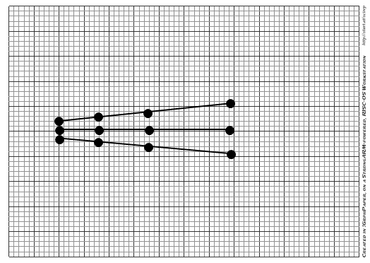

## **9.17 6db Vertical Beam Spread (45º / 60º / 70º)**

Equipment

* A5 block
* Flaw Detector
* Cables
* Shear wave probes
* Couplant
* Ruler
* Pencil

Method

1. Mark line on side of block from holes to scanning surface.
2. Calibrate time base (45° 0 – 100mm, 60° & 70° 0 – 200mm).
3. Target the 13mm hole.
4. Maximize the signal
5. Mark side of block in line with index point.
6. Adjust gain to set the signal to 80% FSH
7. Add in 6 db.
8. Move probe forward until signal drips to 80% FSH.
9. Mark side of block in line with index point.
10. Move probe backwards through original position until signal drips to 80% FSH.
11. Mark side of block in line with index point.
12. Measure distance from mark (in line with hole) to index point marks.
13. Plot these distances on a graph in line with 13mm depth.
14. Repeat steps 3 to 13 for at least three more holes.

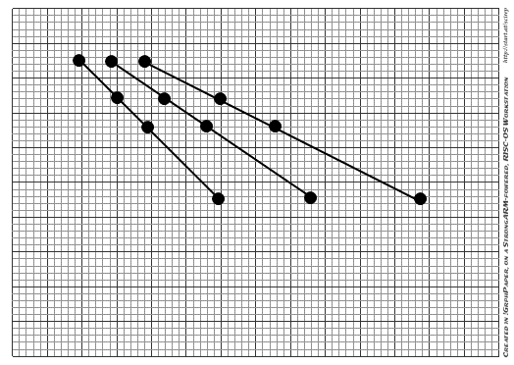

## **9.18 20db Horizontal Beam Spread (45º / 60º / 70º)**

Equipment

* A5 block
* Shear wave probes
* Flaw Detector
* Cables
* Couplant
* Ruler
* Pencil

Method

1. Calibrate time base (45º 0-100mm; 60° & 70° 0 – 200mm).
2. Target the 13mm hole.
3. Maximize the signal.
4. Adjust gain to set the signal to 80% FSH.
5. Add in 20 db.
6. Move probe sideways until signal drops to 80% FSH.
7. Mark top of block in front of probe.
8. Measure distance from side of block to pencil mark and subtract 22mm.
9. Repeat steps 2 to 8 from other side of hole.
10. Repeat steps 2 to 9 for at least three other holes.
11. Plot these reading’s on graph paper

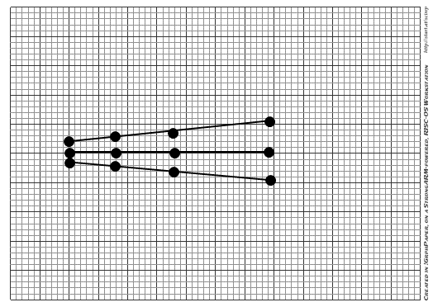

## **9.19 20db Vertical Beam Spread (45º / 60º / 70º)**

Equipment

* A5 block
* Shear wave probes
* Flaw Detector
* Cables
* Couplant
* Ruler
* Pencil

Method

1. Mark line on side of block from holes to scanning surface.
2. Calibrate time base (45° 0 – 100mm, 60° & 70° 0 – 200mm).
3. Target the 13mm hole.
4. Maximize the signal.
5. Mark side of block in line with index point.
6. Adjust gain to set the signal to 80% FSH.
7. Add in 20 db.
8. Move probe forward until signal drips to 80% FSH.
9. Mark side of block in line with index point
10. Move probe backwards through original position until signal drips to 80% FSH.
11. Mark side of block in line with index point.
12. Measure distance from mark (in line with hole) to index point marks.
13. Plot these distances on a graph in line with 13mm depth.
14. Repeat steps 3 to 13 for at least three more holes.

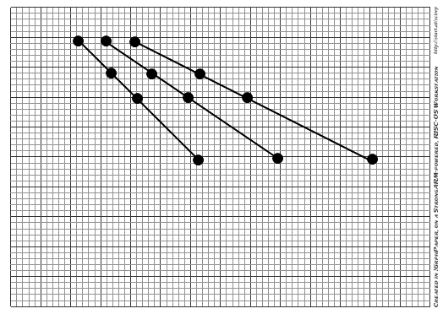

# **WT EQUIPMENT REQUIREMENTS:**

## **10.1    Couplant**

1. The couplant, including additives, shall not be detrimental to the material being examined.
2. Couplants used on nickel base alloys shall not contain more than 250 ppm of sulphur.
3. Couplants used on austenitic stainless steel or titanium shall not contain more than 250 ppm of halides (chlorides plus fluorides).

## **10.2    Coaxial Cables**

1. The condition of the coaxial cables shall be checked prior to use.
2. Any damaged cables shall be replaced.

## **10.3    Probes (Transducers)**

Probes shall be visually inspected, prior to use, for mechanical damage that could interfere with test, damaged probes shall not be used.

## **10.4    Instrument**

1. The instrument shall be sent back to the supplier, on a yearly basis, for calibration in accordance with the Manufacturer.
2. Range calibration shall be done prior to use, before every set of reading taken in accordance with the Manufacturer and/or Reference Code Section.

# **DEFECTIVE EQUIPMENT:**

Any piece of equipment or instrument to be used that does not meet the requirements of the Manufacturer and/or Referenced Code Section shall be tagged and removed from service.

**END**